Taj Brands

Therapeutic Index

Each soft gelatin vaginal suppositories contains.

Composition:
Clindamycin Phospphate BP
equivalent Clindamycin.............................100 mg
Clotrimazole I.P..........................................200 mg
Excipients......................................................q.s.

Indications:
Infective leucorrhoea, mixed infections and non-specific vaginitis, Vaginal Candidiasis bactorial vaginosis & Trichomonasis.
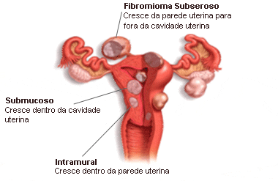
Description:
It interferes with bacterial protein synthesis, by binding to the 50S
subunit of the bacterial ribosome.
This causes antagonism if administered simultaneously and
possible cross-resistance.

Side effects

Adverse reactions associated with the use of clindamycin

phosphate gel include itching and peeling skin.
Cases of diarrhea, bloody diarrhea, and colitis have been reported as adverse reactions in subjects treated with oral and parenteral (intravenous) formulations of clindamycin, and have been reported rarely with topical clindamycin. Abdominal pain and gastrointestinal disturbances, as well as gram-negative folliculitis (bacterial infection and inflammation of hair follicles), have also been reported in association with the use of topical formulations of clindamycin.

Directions for use:
Wash hands thoroughly, before and after insertion of Gynasafe in the vagina. The suppository should be inserted as deep as possible. This is best achieved when lying on the back with legs pulled in little towards the body. After the insertion of Gynasafe no acitivity should be done such as standing, walking, running etc; hence insert while retiring to bed. For best results, take the complete therapy of 3 days. Do not discontinue in the middle. Discontinue only if severe irritation is experienced, only after consulting
Dosage & Administration:
Suppositories should be inserted into the vagina for 3 consecutive nights. Preferably before retiring to bed. Treatment should be timed so as to avoid the menstrual period.
Presentations: 3 Kit
MRP Retailer Stockist
72.00 57.60 51.84

