Taj Brands

Therapeutic Index
MISOBORT TAB
Each uncoated tablet contains:
Composition:
Misoprostol......................................................................100 mcg
Excipients..................................................................................q.s.
Approved colours used
Indications:
Treatment of duodenal, gastric and NSAID induced ulceration. Misobortol should be taken for the duration of NSAID therapy.
Description:
Misoprostol is a synthetic analogue of naturally occurring prostaglandin E1. It has been approved in more than 90 countries for prevention and treatment of gastric and duodenal ulcers. Very few countries have misoprostol registered as an abortion pill. It is safe and well tolerated, and can be kept at room temperature when packed in aluminium blisters.
Outcome of treatment with misoprostol when used orally or vaginally has shown a complete abortion rate of 87% and 95%, incomplete abortion 3% and 4%, missed abortion 3% and 1% and continuing pregnancy in 7% and 1% respectively.
Misoprostol is rapidly absorbed after oral administration and converted to its pharmacologically active metabolite, misoprostol acid. Plasma concentrations of misoprostol acid peak in approximately 30 minutes and decline rapidly thereafter.
The effects of misoprostol on the reproductive tract are increased, and gastrointestinal adverse effects are decreased, if this is administered vaginally. On vaginal administration, the plasma concentrations of misoprostol acid peaks in 1-2 hours and then declines slowly. Vaginal application results in slower increase and lower peak plasma concentration of misoprostol acid than does oral administration. Uterine contractility increases and then plateaus one hour after oral administration, whereas, contractility continues for four hours after vaginal route.
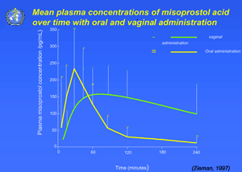
Dosage :
The recommended adult oral dose for the treatment of duodenal, gastric and NSAID induced ulceration is 200 mcg 4 times daily with food and at bedtime for 4-8 weeks.
If this dose is not tolerated, a dose of 100 mcg can be used.
Presentations : 4 tablets
MRP Retailer Stockiest
51.00 40.80 36.72

